Template Patent Document

Title of invention: ____________________________________

Drawings: (with reference numerals associated with the parts)

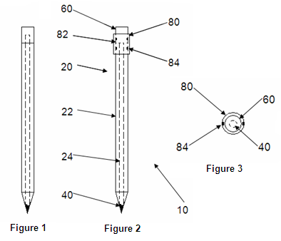

Parts list:

Reference numeral | Part name
10 | [Enter, e.g. pencil]
22 | [Enter, e.g. body]
24 | [Enter, e.g. writing element]
82 | [Enter, e.g. collar]
60 | [Enter, e.g. eraser]

Part description:

The [part] is [enter description]

The [part] is [enter description]

Example:

The body 22 is: elongate; made of wood; circular, octagonal or hexagonal in axial cross-section; and defines an axially extending bore.

The writing element 24 is cylindrical and made of graphite. The outer diameter of the writing element 24 corresponds to the diameter of the bore defined by the body 22, and the axial length of the writing element 24 is at least equal to the axial length of body 22.

The collar 82 is: cylindrical, defining an axially extending bore; and is made of steel. The inner diameter of the collar 82 corresponds substantially to the outer diameter of the body 22.

The eraser 60 is a solid elastomeric body that is cylindrical in shape. The outer diameter of the eraser 60 corresponds substantially to the inner diameter of the collar 82.

Assembly:

[Describe how the parts are assembled]

Example:

The writing element 24 is disposed within the bore defined by the body 22, and secured therein either by an adhesive or a friction fit.

A first axial end of the body 22 is partly received axially within the bore defined by the collar 82, and the collar is crimped to secure the collar 82 to the body 22. Similarly, the eraser 60 is partly received axially within the bore defined by the collar 82, and the collar is crimped to the eraser 60 to secure the collar 82 to the eraser 60.

In use:

[Describe the invention “in use”]

Example:

In use:
- the second axial end of the body 22 is shaved into a conical shape, thereby to cause the writing element 24 to protrude from the body 22; and
- the exposed portion of the writing element 24 is used to write on paper. Should the user wish to erase a pencil marking, the pencil 10 is rotated and the eraser 60 is rubbed against the marking.

__________________________

Applicant’s signature

name: _____________________

Filing your provisional patent application

- Go to https://globalipco.com
- Complete the application form
- Sign the patent application forms that the GlobalIPCo system generates
- Upload the signed forms, this description and the drawings
- Pay $199

Within a day you will receive your provisional patent application number / Patent Pending Number. Thereafter, start freely disclosing your product, make sales and add it to your website.

In 12 months’ time, file corresponding complete patent applications in countries in which you wish to secure patent protection.

